Power Platform M365 Central Site Pages

This document shows the as-is (current) Power Platform Site pages in the M365 Central.

Many of these pages are outdated or need to be revamped and or replaced.

Recommendations:

1. Make the pages more intuitive as to what people want. While the data in here currently is all good, it is generally not what we tell to users or what users ask us when getting started. Formulate the way we want to get across to the people for instance:
   1. Example:
      1. **Home Page** (who we are, what we do, how to contact us – include a basic description and diagram of the request process with links to each area)
         1. I recommend we keep this page mostly as it is.
         2. I would group the Power Apps, Power Automate, Power BI and Pipelines all under Power Platform, and provide a short description of each with a link to a detail page for each.
            1. Each linked page should give a break down of what the Service is used for, and basic of how to operate, and limitations or governance, as well as links to code standards for each.
         3. I would include a new section that provides a link, but should give a short synopsis of a Step by Step process of how to go from development to Production
         4. Under Objectives I recommend we either replace the objectives, or remove the section all together.
         5. Provide a Contact Email for our group, as well as POCs, and finally a link to Power Platform User Group (PPUG)
      2. *Power Platform Connector*
         1. I would remove this whole page, and instead have a link within the Step By Step process as well as perhaps within each of the Service detail pages (Apps, Flows, BI) to t he Microsoft Power Platform Connector page, and instruct them to look for only those supported by GCC and even then, not all have been approved by IRS.
      3. **Environment Types AND Development Tiers**
         1. I think these should be combined with the following in mind (Combine the elements of these two pages, as they talk about the same things.):
         2. Basic understanding of personal (Personal Productivity), Business, and dedicated environment needs.
         3. The need for a Dev (Sandbox), Test and Production environments for each (except for Personal productivity).
      4. **Power Platform – request an Environment – (Step By Step Request Process)**
         1. I would change this to the Step by Step process page I mentioned in the Home page area.
         2. I would provide links to either images, or individual pages that provide sample filled-out forms of Service Now for requesting environments, Security Groups, and Pipelines
      5. Create a **Power App (sub-page)** – this should be a reference page, with no direct access from navigation
      6. Create a **Power Automate (Flow) (sub-page)** – this should be a reference page, with no direct access from navigation
      7. Create a **Power BI (sub-page)** – this should be a reference page, with no direct access from navigation
      8. Create a **Pipeline (sub-page)** – this should be a reference page, with no direct access from navigation
         1. Power Platform Solutions: Talk about what is expected from us in terms of how to create production quality Apps, Flows, and BI workspaces, with the following sub-pages
            1. Requesting Environments
            2. Solutions
            3. Power Apps
            4. Power Automate
            5. Power BI
         2. Power Platform Environments
            1. The Personal Productivity environment – its purposes, its limitations, and its
            2. The different “types” of environments that we support and do not support (i.e. Developer, Sandbox, Trial, Production, Team)
            3. The general set up of environments (i.e. Sandbox (Dev), Test, Production)
         3. Pipelines
            1. What pipelines are
      9. Create a **Premium Connection (sub-page)** – this should be a reference page, with no direct access from navigation
         1. Specify in particular SQL, Oracle, Dataverse, and other commonly used Premium connectors that should have more detailed information.

* [M365 Central - Home](https://irsgov.sharepoint.com/sites/M365_Central/SitePages/M365_PowerPlatform_Top_Landing_Page.aspx) (https://irsgov.sharepoint.com/sites/M365_Central/SitePages/M365_PowerPlatform_Top_Landing_Page.aspx?csf=1&web=1&e=aegmEq)

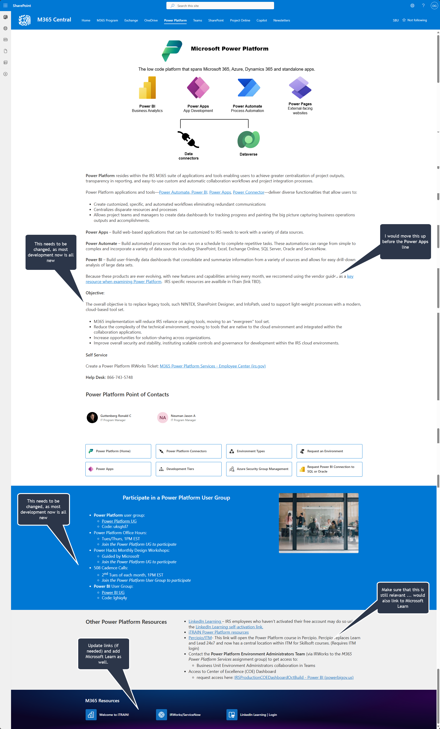

* [M365 Central - Home](M365%20Central%20-%20Home) (https://irsgov.sharepoint.com/sites/M365_Central/SitePages/M365_PowerPlatform_Connectors_Page.aspx?csf=1&web=1&e=kj3592)

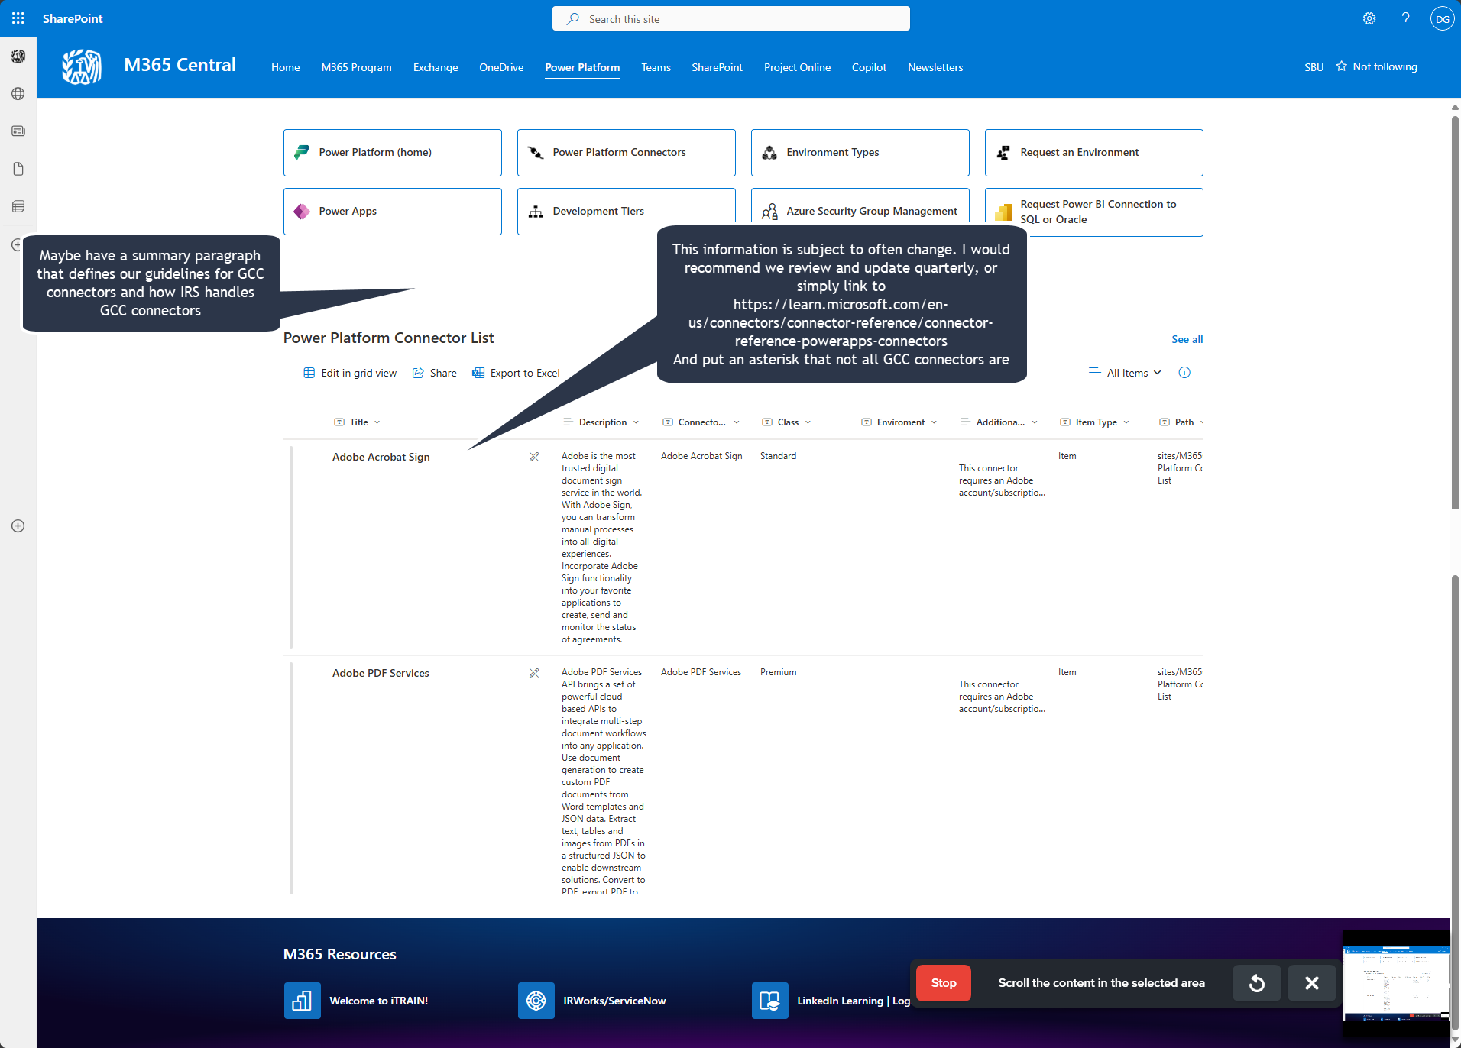

* [M365 Central - Home](https://irsgov.sharepoint.com/sites/M365_Central/SitePages/M365_PowerPlatform_Environ_Types_Page.aspx) (https://irsgov.sharepoint.com/sites/M365_Central/SitePages/M365_PowerPlatform_Environ_Types_Page.aspx)

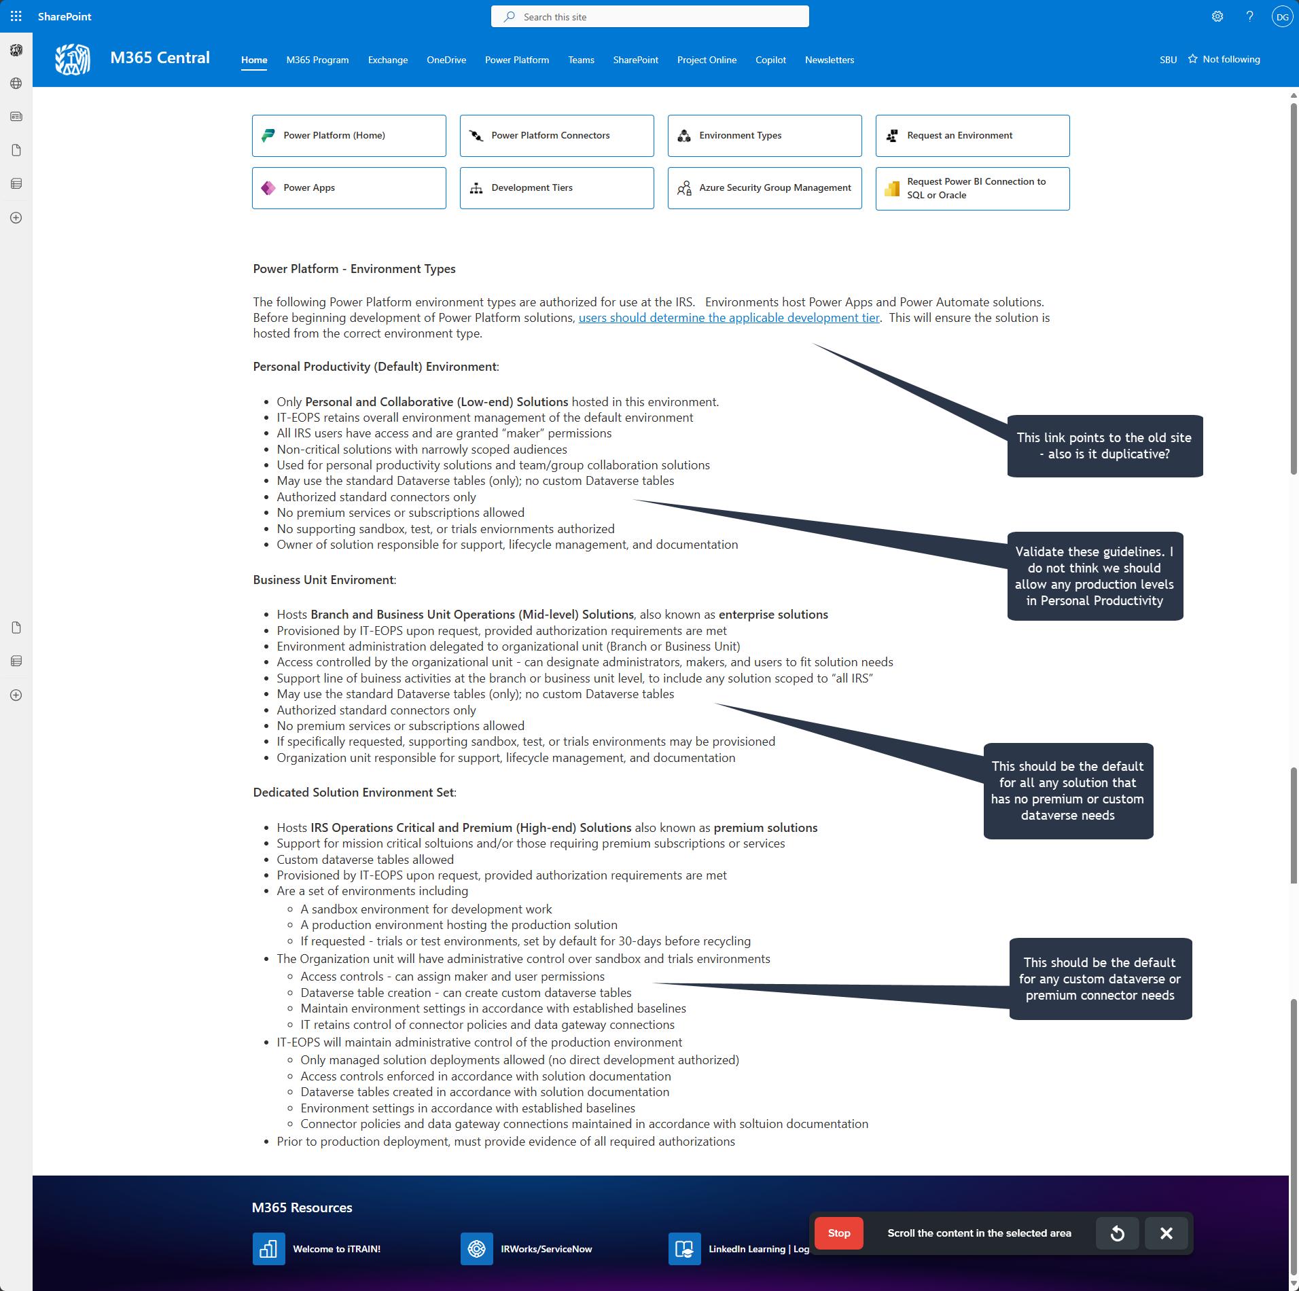

* [M365 Central - Home](https://irsgov.sharepoint.com/sites/M365_Central/SitePages/M365_PowerPlatform_Environ_Reqs_Page.aspx) (https://irsgov.sharepoint.com/sites/M365_Central/SitePages/M365_PowerPlatform_Environ_Reqs_Page.aspx)

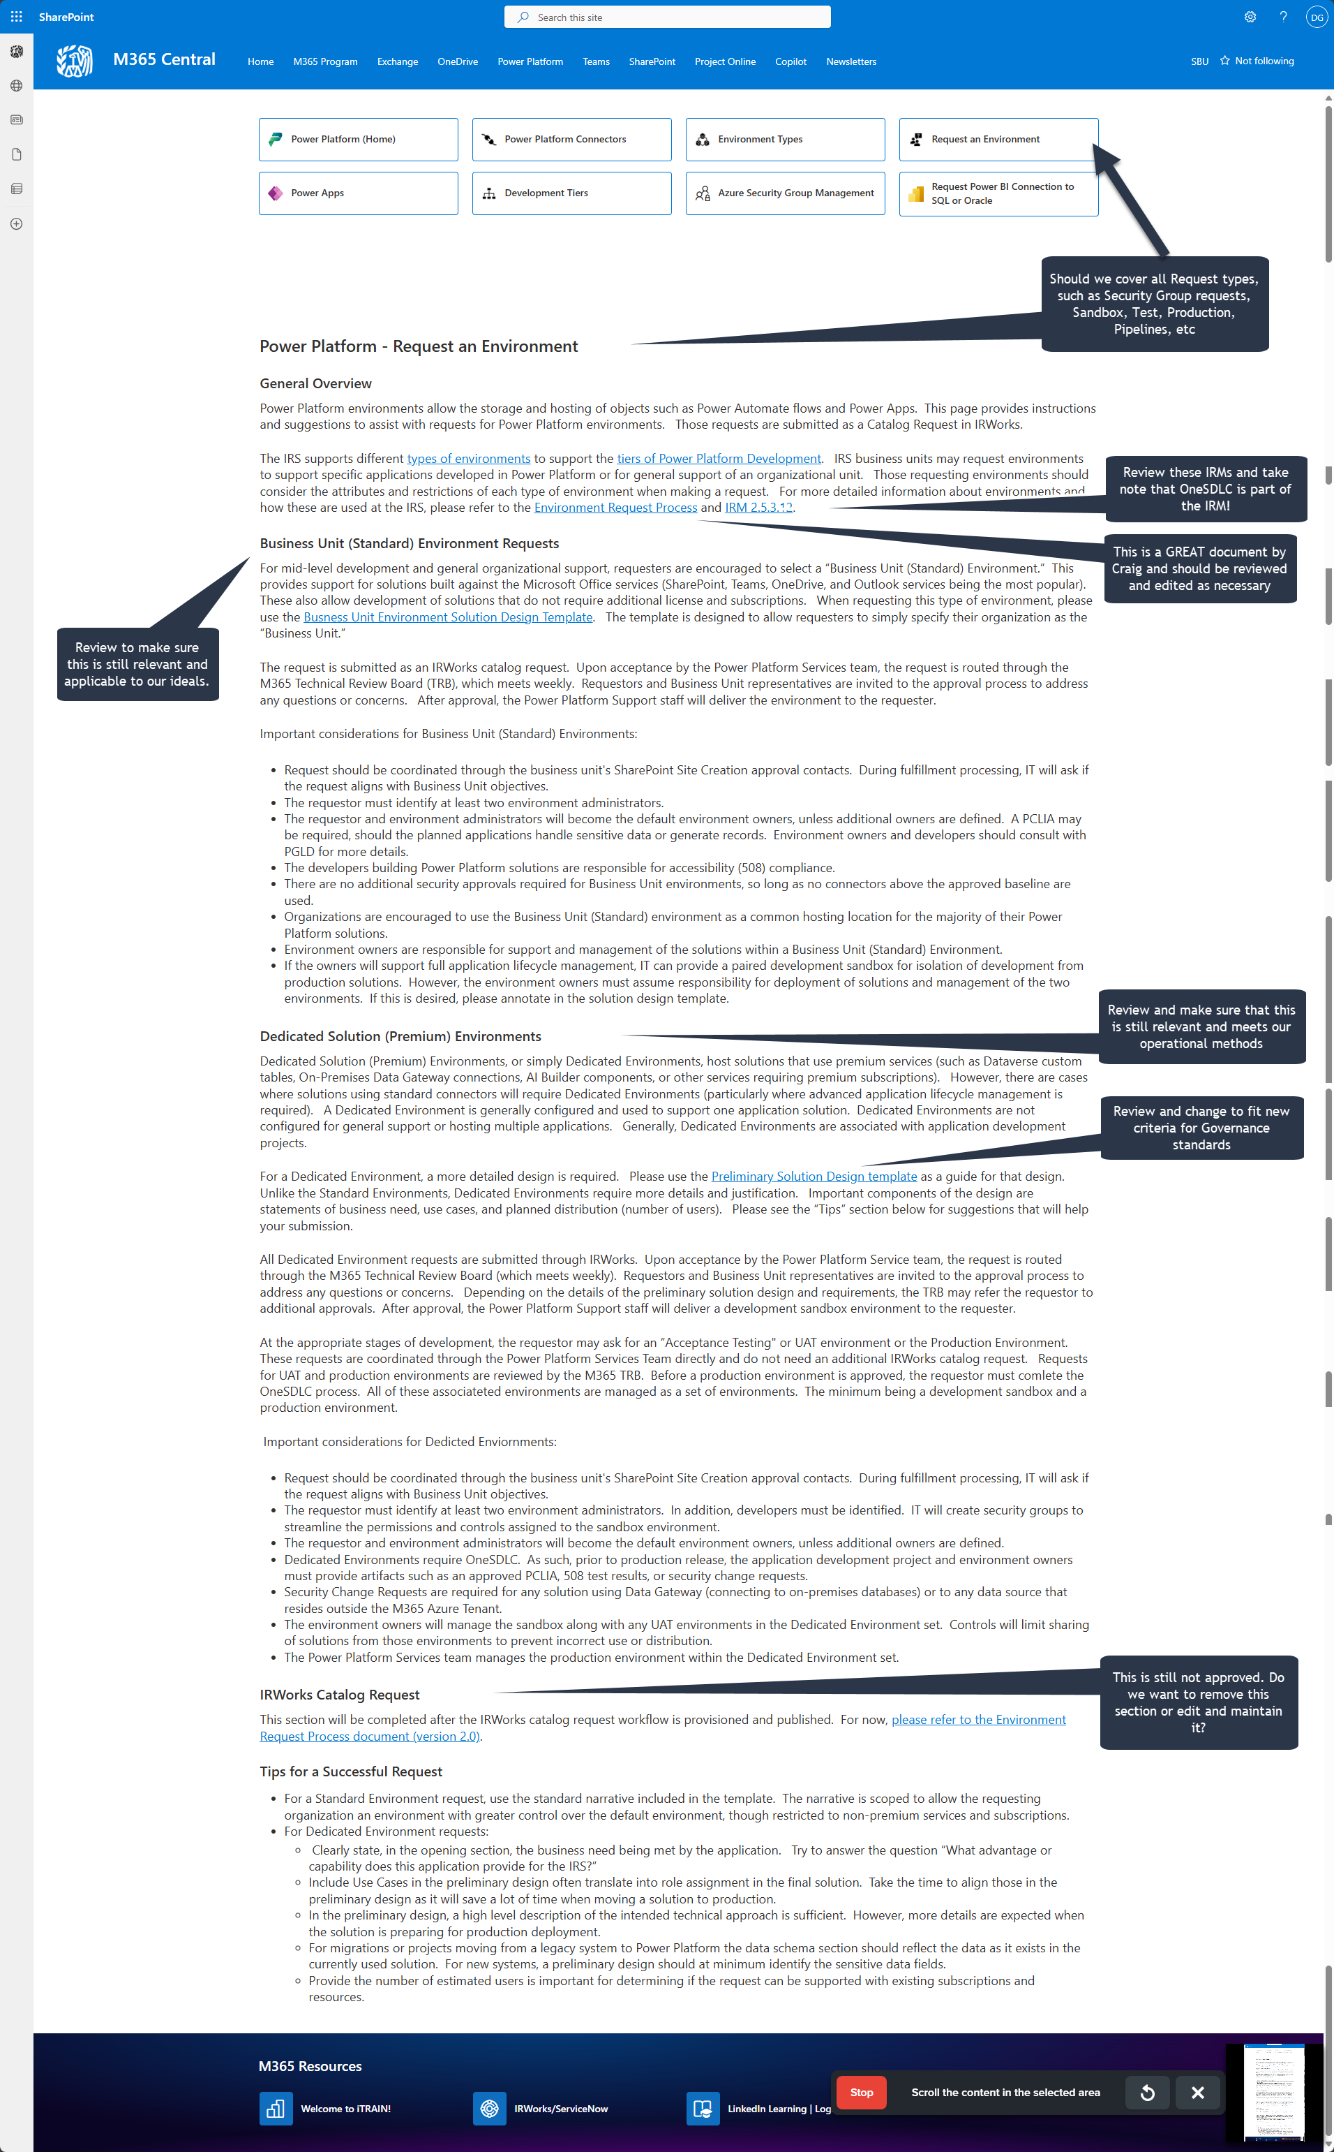

* [M365 Central - Home](https://irsgov.sharepoint.com/sites/M365_Central/SitePages/M365_PowerPlatform_Page.aspx) (https://irsgov.sharepoint.com/sites/M365_Central/SitePages/M365_PowerPlatform_Page.aspx)

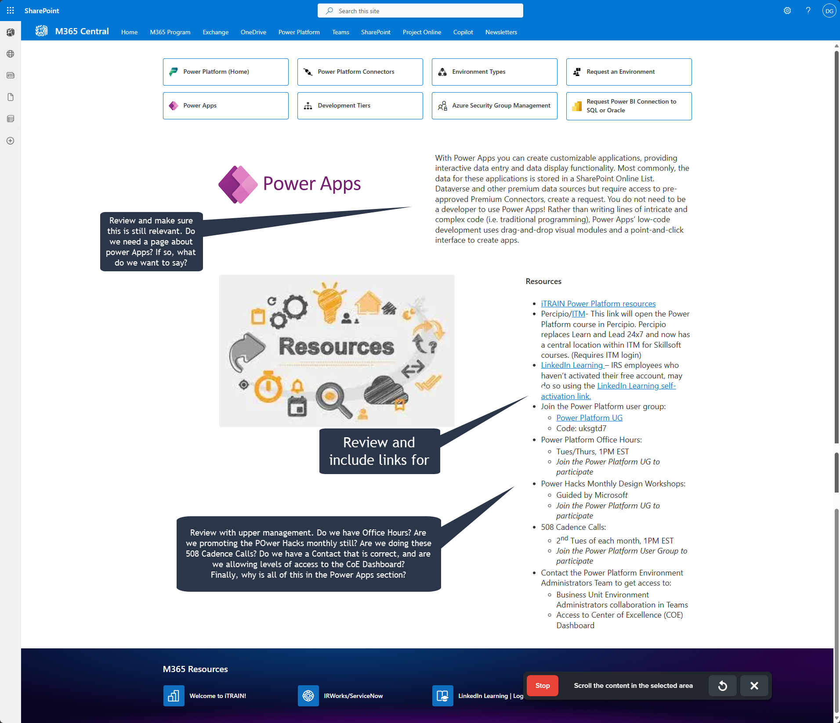

* [M365 Central - Home](https://irsgov.sharepoint.com/sites/M365_Central/SitePages/M365_PowerPlatform_Dev_Tiers_Page.aspx) (https://irsgov.sharepoint.com/sites/M365_Central/SitePages/M365_PowerPlatform_Dev_Tiers_Page.aspx)

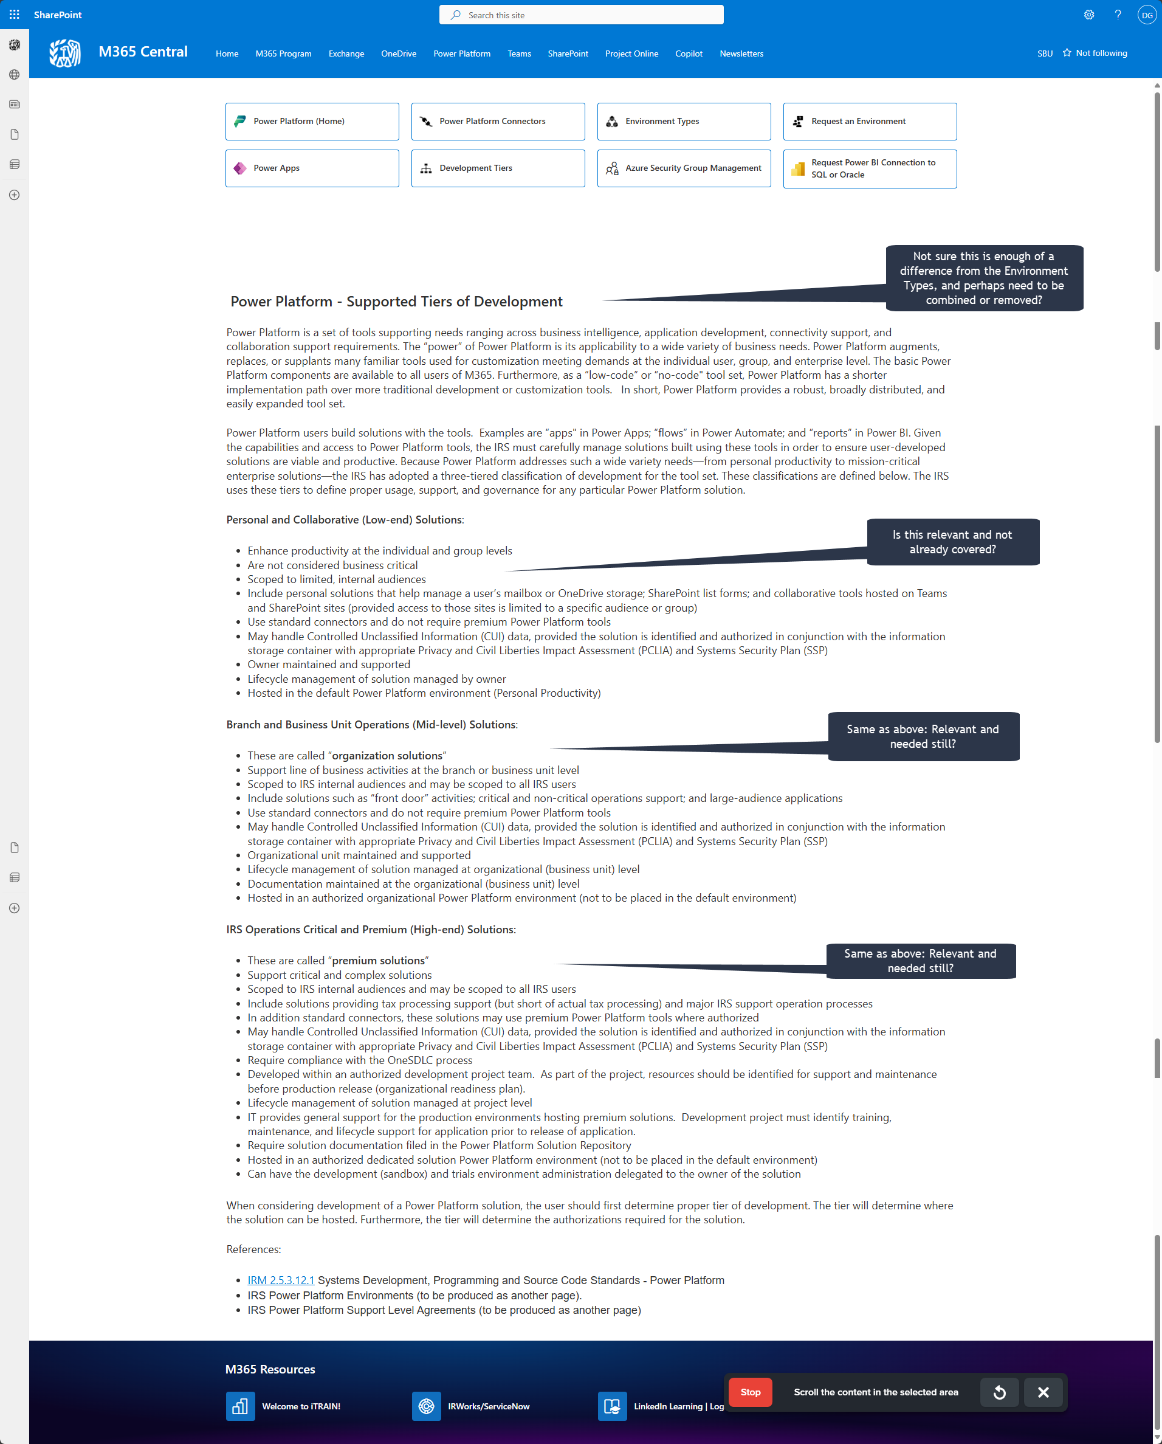

* [M365 Central - Home](https://irsgov.sharepoint.com/sites/M365_Central/SitePages/M365_Azure_Security_Page.aspx) (https://irsgov.sharepoint.com/sites/M365_Central/SitePages/M365_Azure_Security_Page.aspx)

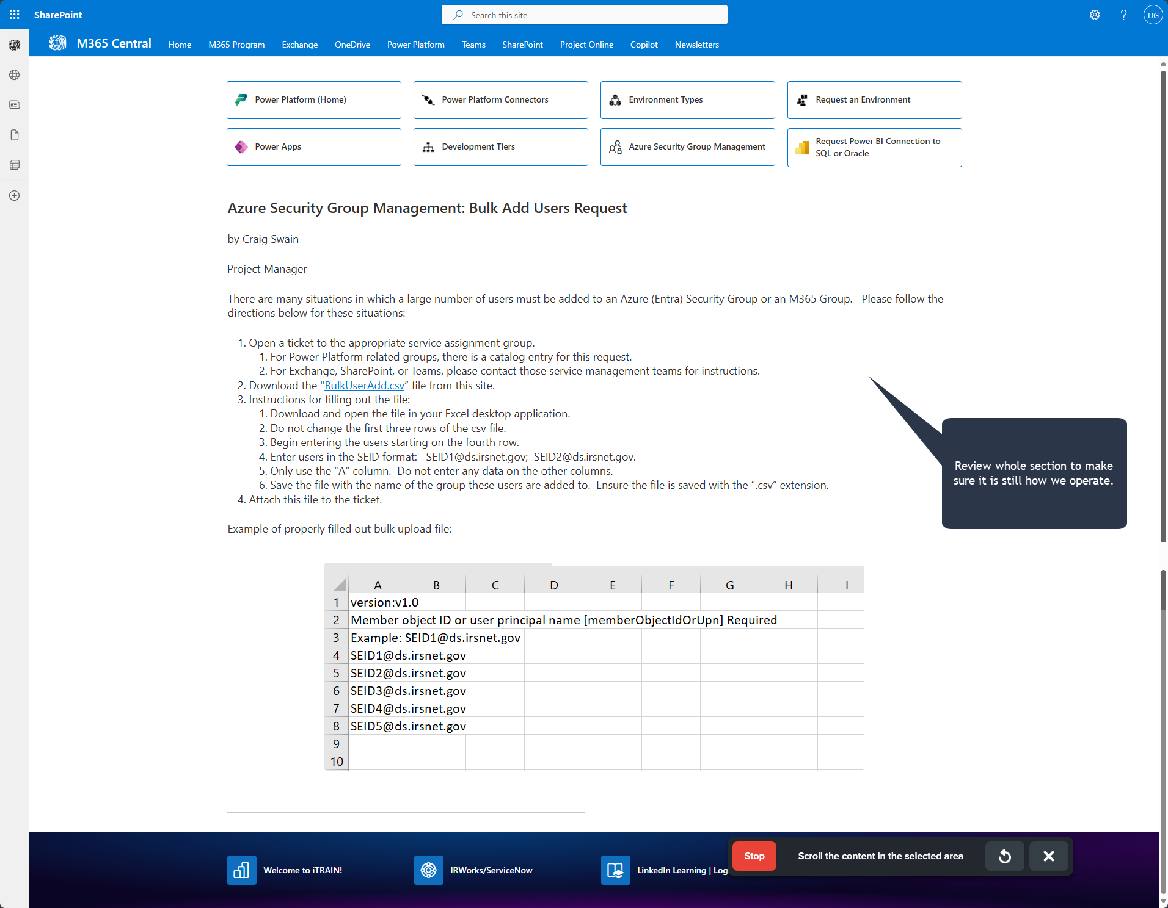

* [M365 Central - Home](https://irsgov.sharepoint.com/sites/M365_Central/SitePages/M365_PowerPlatform_RequestPBIConnection_Page.aspx) (https://irsgov.sharepoint.com/sites/M365_Central/SitePages/M365_PowerPlatform_RequestPBIConnection_Page.aspx)

